Effects of decomposition, sampling depth, and body condition on biomarkers that reflect stressors in blubber tissue of stranded gray whales

Valentina Melica¹, Shannon Atkinson¹, Jessica Huggins², Matthew Rogers³, Bryan Cormack³, Debbie Duffield⁴, Dalin D'Alessandro⁴ and John Calambokidis²

¹ University of Alaska Fairbanks, College of Fisheries and Ocean Sciences, Fisheries Department, Juneau, USA.
² Cascadia Research Collective, Olympia, USA.
³Alaska Fisheries Science Center, NOAA; Juneau, USA
⁴Portland State University, Biology Department, Portland, USA

TO DISCUSS:
We are including the following variables:
- Cortisol, Corticosterone
- Aldosterone
- Lipid %
In relation to:
- Blubber depth (1, 2, 3)
- COD ( 1,2)
- Body condition (1,2,3)
- Age and sex (1,2, 3)

ABSTRACT
Gray whales (Eschrichtius robustus) from the Eastern North Pacific Ocean experienced an unusual mortality event between 2019 and 2023, with unexpected high numbers of stranded individuals. Blubber from stranded whales is used for a variety of analyses that can help elucidate the physiological well-being of the individual, including the investigation of endocrine biomarkers and lipid content. However, cause of death, sampling location and depth, as well as the body condition of the animal at the time of death can potentially affect the biochemistry of these compounds. The goal of this study was to investigate the variability in total lipid, cortisol, corticosterone, and aldosterone concentrations across the full blubber depth from 35 individual gray whales stranded in Washington and Alaska between 2010 and 2019. The state of carcass decomposition, nutritional condition age, sex, ad cause of death of the individual, were also accounted for. Full-depth blubber was subsampled at three different distances from the skin: Surface (0-2 cm), Middle (3-6 cm), Bottom (> 6). Indices of Good, Fair and Poor body conditions were assigned by field responders and recovered from stranding reports. Overall, cortisol and aldosterone concentrations, but not total lipids, were affected by sex and age class, with immature females having significantly higher concentrations. Concentrations of all three hormones and total lipid (as a percent of mass analysed) were higher in the surface layer, but the difference was significant only for cortisol (p =0.05) and total lipid (p<0.05). Cortisol and corticosterone concentrations showed similar trends among cause of death with individuals that perished due to trauma or nutritional stress having elevated concentrations. Aldosterone concentrations were lowest in individuals that perished due to trauma, and highest in individuals that died after a predation event. However, no statistical difference was detected for any of the three hormones. Body conditions appeared to affect each hormone differently, with no significant differences were detected, although total lipid content and corticosterone were correlated (r=0.4, P=?), suggesting this hormone may play an important role in lipid metabolism. ADD another sentence discussing the findings and what they may mean. These findings further our understanding of using bioindicators for metabolic well-being in health assessments of large whales.

Introduction
Gray whales occur exclusively in the Pacific Ocean (Rice et al., 1984) and two populations are recognized, Western (WNP) and Eastern North Pacific (ENP) populations, with overlapping feeding grounds in the eastern North Pacific (Mate et al., 2011). While the WNP population is still considered as critically endangered, the ENP population was removed from the U.S. endangered species list in 1994. Abundance estimates indicate the ENP population has reached carrying capacity at 20,000 – 22,000 individuals (Swartz, 2018), and the most up-to-date estimate is approximately 27,000 individuals (Durban et al., 2017). The majority of ENP gray whales migrate annually between the lagoons of the Baja Peninsula, their breeding grounds, and the continental shelves of the Bering, Chukchi, and more recently the Beaufort Seas, to feed. An exception is the Pacific Coast Feeding Group (PCFG), a small group that forage primarily between southeastern Alaska and Northern California (Calambokidis et al., 2012). Migration and reproduction are tightly connected, as the migrating groups are staggered in time based on sex and reproductive states (Rice and Wolman, 1971; Swartz, 2018).
Gray whales are considered ecosystem sentinels (Moore 2008) due to their feeding ecology and migratory patterns which are likely affected by changes in prey composition driven by climate or oceanographic perturbations. As they forage on lower trophic levels, primarily on benthic amphipods and decapods, and are seasonally present in the Arctic, gray whale migration is affected by the Pacific Decadal Oscillation, El Niño-La Niña oscillations, and sea ice (Moore et al., 2007, 2003; Perryman et al., 2002; Urbán et al., 2003). Along their migrating route, gray whales are exposed to a variety of anthropogenic sources of disturbance, such as contaminants (Gulland et al., 2005; Krahn et al., 2001; Tilbury et al., 2002), underwater noise (Moore and Clarke, 2002), fishing operations and ship collisions (Baird et al., 2002; Douglas et al., 2008). Studies from the late 1980s reported avoidance and change in behavior due to noise disturbance comparable to drilling operations and air guns arrays (Malme et al., 1988; Moore and Clarke, 2002). Furthermore, given their foraging habit, gray whales are likely to ingest and accumulate chemical contaminants: even if no toxic concentrations have been reported in stomach content and blubber tissue of this species (Krahn et al., 2001; Varanasi et al., 1994; Hayes ). Even at low quantities organic contaminants may act as endocrine-disrupting chemicals, external compounds that can alter normal hormone function (Fossi and Marsili, 2003). Long-term effects of endocrine disrupting chemicals include reproductive failure, poor body conditions and adrenal gland damage (Godard-Codding and Collier, 2018). In 1999 – 2000, the ENP population of gray whales experienced an Unusual Mortality Event with more than 600 carcasses reported, with starvation as a contributing factor to mortality (Gulland et al., 2005). In 2019, more than 200 animals were found stranded across Mexico, United States and Canada and NOAA has issued a second UME (NOAA, 2020). While no common cause of death has been identified, many carcasses were in poor body conditions.
The speed and intensity of climate and oceanographic changes in marine ecosystems and the increased wildlife-human interactions warrant the need to search for biomarkers for assessing the physiological well-being and possible stress responses. Prolonged exposure and stimulation of an endocrine response to any number of stressors may be detrimental to reproduction (Atkinsnon et al., 2015; Tilbrook et al., 2000; Wasser et al., 2017) and immune system function (Webster Marketon and Glaser, 2008), potentially leading to population decline (Wasser et al., 2017). Corticosteroids are involved in the physiological response to stress in terrestrial and aquatic mammals (Atkinson et al., 2015); however, there is a paucity of published research on physiological processes in large whales and specifically on stress-related endocrine profiles. Cortisol and corticosterone are secreted by the adrenal glands and are involved in maintaining metabolic homeostasis, including the stress response, with their main function being stimulation of gluconeogenesis to sustain the energetic requirements (Atkinson et al., 2015; Peckett et al., 2011; Tanaka et al., 2017). Aldosterone is another adrenal hormone and is primarily regulated by the rennin-angiotensin system. It mainly acts to regulate electrolyte balance, water retention and blood pressure (Kubzansky and Adler, 2010). When secreted excessively or over a prolonged period of time, these hormones can have detrimental effects on skeletal muscle and on the reproductive and cardiovascular systems.
Steroid hormones have been measured in a variety of tissues in multiple wildlife species. When available, blood serum, and feces are the matrices of choice for investigating endocrine response to very recent events (minutes to hours) (Atkinson et al., 2015, 1999; Burgess et al., 2017; Champagne et al., 2017; Hunt et al., 2006; Keogh and Atkinson, 2015; Robeck et al., 2017; Rolland et al., 2019, 2012, 2005; Steinman et al., 2016; Valenzuela-Molina et al., 2018), whereas for life-long endocrine profiles, steroid hormones have been extracted and measured in earplug and baleen plates (Hunt et al., 2018, 2017, 2014; Trumble et al., 2018, 2013). An increased number of studies have focused on blubber, as samples can be obtained with minimally invasive techniques and reflect close-to-recent physiological processes (Atkinson et al., 2019; Cates et al., 2020, 2019; Champagne et al., 2018; Kellar et al., 2015; Mingramm et al., 2020; Trana et al., 2015).
Blubber is common to most marine mammals, and it consists of a vascularized layer of fat and connective tissue beneath the skin (Iverson and Koopman, 2019). Energy storage is the main function for this tissue; however, it also serves as a thermal insulator and aids buoyancy and hydrodynamics (Iverson and Koopman, 2019). Being a dynamic tissue, blubber changes in response to reproductive status, nutritional status, and age (Iverson and Koopman, 2019). Steroid hormones are synthesized from cholesterol and because of their lipophilic nature, blubber is a suitable tissue for endocrine analysis. Additionally, recent studies have shown that accumulation of steroids in this tissue occurs within hours from their secretion in blood (Champagne et al., 2018, 2017), suggesting that blubber can be used to describe recent physiological events.

LIPID CONTENT
IMPORTANCE OF STRANDED SAMPLES

The overall goal of the present study was to investigate corticosteroids and lipid content in blubber samples of stranded gray whales that had a variety of causes of death. Specific objectives included:
  - To evaluate corticosteroid hormone concentrations in relation to sex, age class
  - To evaluate corticosteroid hormone concentration in relation to blubber depth, body conditions and state of carcass decomposition;

  - To compare hormone concentrations in stranded animals that perished of different causes of death.
The expected outcome will be to better understand how different life history traits and physiological parameters either influence or may be influenced by varying stressors. In doing so, the ability to predict the severity or duration of future unusual mortality events may influence the success of conservation measures.

Methods

Individual Samples
Blubber samples from 35 (22 females and 13 males) gray whale carcasses were obtained through the United States Marine Mammal Health and Stranding Response Program (MMHSRP). These samples came from whales that were found and examined between 2010 and 2019, along the coasts of Washington (n= 28) and Alaska (n=7). Out of 35 individuals, 19 were part of the 2019-2022 UME. Information on the animal (e.g., sex and length) as well as likely cause of death (COD), body condition and carcass condition were obtained from the MMHSRP Level A forms and necropsy reports. Age class was primarily determined by the measured length and categorized as immature (body length lower than XX; n= 14) and adult (length greater than XX, n= 19). Age class was not assigned to two individuals. The
initial report assigned each animal one out of 4 categories of body condition that ranged from Excellent to Good to Fair, to Poor; however, due to limited sample size the categories of Excellent and Good were combined. Similarly, carcass conditions were rated on a scale of 2 to 4, with 0.5 increments, where 2 indicated a fresh carcass, 3 was a carcass with moderate decomposition, and 4 was a highly decomposed carcass. The cause of death (COD) was determined as:
Trauma (n= 10), when signs of a blunt or traumatic impacts were present on the carcass, including collision with vessels;
Nutritional stress (n= 12), when the animal was found severely emaciated;
Entanglement (n= 2), when found entangled in fishing line (one of the animals was a live stranding);
Predation (n= 3), when the animal showed signs of attacks from killer whales (e.g. rake marks, bite makes) or was known to have been harvest. For 8 individuals, COD was not determined.

Hormone extractions, validation and measurement
Full blubber depth samples were subsampled at their storage at three MMHSRP locations and transferred to the University of Alaska Fairbanks facility in Juneau AK, where they were stored at -80°C until further processing. Blubber depth ranged between 6 to 12 cm. Each sample was subsampled along three depth categories: “Surface” from skin to 2 cm depth, “medium” from 3 to 6 cm, and “bottom” from > 6 cm blubber depth. The mass of subsamples ranged between 0.096 and 1.270 g (mean ± standard deviation= 0.23 ± 0.18 g) for all whales. Hormone extraction was performed following the step-wise process described in Atkinson et al. (2019) adapted from Kellar et al., (2006) and Mansour et al., (2002). Briefly, samples were first macerated manually using a Teflon tip homogenizer in 1 ml of ethanol, then extracted using a series of solvent-supernatant transfers, with multiple organic solvents (ethanol, acetone, ether, acetonitrile and hexane). Extracts were diluted in 1 ml of methanol before being aliquoted for each assay, dried under forced air and rehydrated with assay buffer. Hormone concentrations were measured using enzyme immunoassay (EIA) from Arbor Assay (Ann Harbor, MI) for cortisol (Catalog number # K003), corticosterone (# K014) and aldosterone (# K052), following the manufacturer’s protocols. Analytical validation (parallelism and accuracy test) and biological validations for cortisol and corticosterone are reported in Melica et al. (2022), validation of aldosterone is presented below. For each sample, hormones measurements (in pg/ml) were corrected for dilution factor and extracted blubber mass, and expressed as ng/g. The intra-assay coefficient of variation (CV) was <10%, for all hormones. If any sample had a CV >10%, it was re-diluted accordingly and re-assayed. Inter-assay validation was determined using two internal controls for each hormone. For the corticosterone assay, the CVs (%) of the internal controls used were 16.9% and 10.9%; for cortisol, 12.2% and 15.6%; for aldosterone, 11.5% and 11.2%.

Validation of aldosterone EIA for gray whale blubber

Analytical validation for aldosterone was performed testing pools of extract from males (n=8) and females (n=8) for parallelism and accuracy. To test for parallelism, each pool was serially diluted (1:1, 1:2, 1:4, 1:8, 1:16 and 1:32) and tested for parallel displacement with the standard curve. This step is used to confirm that the assay antibody can reliably bind the antigen throughout the range of the standard curve. It also indicates at what dilution hormone concentration shows to 50% binding. Parallelism was assessed both visually and using a t-test to determine statistical differences in slopes, with lack of significance supporting parallelism. The accuracy test is used to determine if any other compounds in the extracts are interfering with the antigen-antibody binding of the assay, testing how well the measured concentrations corresponded to added concentrations of each hormone. For this step, an equal volume of each pool was spiked with each standard, the recovered mass was graphed against the added mass and it was tested for linearity. Linearity is met when a linear slope close to 1.0 (acceptable range: 0.7 – 1.3) is achieved (Hunt et al., 2017b).

Lipid extraction and measurement
TBD

Statistical Analysis
UME vs non UME
- Log transformed Cts- t test indicated no significant difference. For this hormone they can be divided in the remaining COD groups (#t = 1.6646, df = 31.991, p-value = 0.1058)
- Same results for log transformed corticosterone #t = 0.97649, df = 28.862, p-value = 0.3369
- Conclusion: if we remove the outlier there is no significant difference in aldosterone concentrations between samples collected before or during the UME
Lets operate then to reassign COD

All statistical and graphical analyses were conducted using the software R v.3.5.2 (R Core Team, 2020). Exploratory analysis to assess normality and homogeneity of variances was conducted on both the row data and residuals from fitted linear models.
When normality requirements were met , linear models and parametric tests (ANOVA, Student’s T-test, Tukey post-hoc) were applied. Otherwise, corresponding non parametric options (Generalized linear model, Kruskal-Wallis and Wilcoxon tests) were chosen.

Age-class and sex
For the analysis of hormone concentrations and lipid content in relation to age class and sex, the dataset was filtered to include individuals of known age class and sex. Generalized linear models were fitted to cortisol, corticosterone, and aldosterone concentrations in relation to age class, sex and the interaction of both. The models were then compared among them and to the null model using the Akaike Index Criterion for small sample size (AICc). For all AICc analyses, the model with the lowest AICc was considered the best option. A post-hoc test comparing estimated marginalized means (EMM) was applied to determine if there was any statistical difference in hormones concentrations and lipid content.

Analysis of hormone concentrations across blubber depth was accomplished with a
final datasets of 19 individuals for cortisol, of which 17 had values across all three blubber depths; 16 individuals for corticosterone with values of all blubber depths; 12 individuals for aldosterone, with 10 values across all three categories of blubber depth. Exploratory data analysis indicated that hormone concentrations did not meet the requirement for parametric test. Additionally, Pearson a correlation test indicated corticosterone to be positive correlated with cortisol (r = 0.49) and aldosterone (r= 0.65).
To determine the effect of blubber depth on hormone concentrations and lipid content, generalized mixed effects models (function lmer in package lme4 CIT) were developed with blubber depth as fixed factors and whale ID as a random factor. The model was then compared to the null model using the Akaike Index Criterion for small sample size (AICc). A post-hoc test comparing EMM was applied to determine if there was any statistical difference in hormones concentrations and lipid content across blubber depth (emmeans).

For the analysis of hormone levels in relation to cause of death,
hormone concentrations for all three hormones were log-transformed to meet normality requirements and compared across COD using ANOVA, followed by a post-hoc Tukey test.
.
For the analysis of hormone concentrations and lipid content in relation to body condition
, only individuals with body conditions listed as GOOD, FAIR and POOR were compared. Outliers for corticosterone and aldosterone were also removed from the data. Because hormone concentrations in relation to COD did not meet normality requirements (using Shapiro Wilk test on residuals), a non-parametric test for analysis of variance (Kruskall-Wallis) was used to test for significant differences.

Results
Validation of Aldosterone
Parallel displacement to the standard curve of the serial dilutions from the male and female blubber pools were confirmed visually and statistically for both sexes (p >0.05) (Table 3.2; Fig. 3.1C); for the accuracy check the standard mass recovered showed linear relationships with the mass added for both species and sexes, with slopes ranging from 1.0 to 1.3 (Table 3.2). The serial dilutions from the gray whale blubber showed 50% binding at 1:1 and 4:1, for females and males respectively.

Analysis of hormone concentrations and lipid content in relation to age class and sex

The model including the interaction of sex and age class as predictors was found as the best model to explain cortisol concentrations (AICc= 233.2), with immature females showing statistically different concentrations from adult males and adult females. Mean (± sd) cortisol concentrations were significantly elevated in immature females (17.30 ± 14.50 ng/g, n=8) compared to adult females (4.59 ± 3.63 ng/g, n=11; t(28)= -3.35, p= 0.01) and adult males (3.79 ± 3.51 ng/g, n=7; t(28)= 3.19, p= 0.02 whales. However, this difference was driven by the two outliers with concentrations higher than 30 ng/g, both measured in immature females. When those were removed, the model including age class, without sex, became the best model (AICc=187.1) and a significant difference was found in cortisol concentrations between immature and adult individuals (t(28)= -2.1, p= 0.05).
For corticosterone, the model with age class as explanatory variable was identified as the best model (AICc=182.3). Mean corticosterone was significantly higher in immature individuals (3.5 ± 5.6 ng/g, n=13) than in adults (1.3 ± 2.0 ng/g, n=19, Wilcoxon rank sum test : W = 64, p-value = 0.02). One immature female had concentrations > 20 ng/g. Once removed, the model including sex as explanatory variable was identified as the best model (AICc= 128.3). Mean corticosterone concentrations were not different between females (1.9 ± 2.0 ng/g, n=19) and males (1.0 ± 1.2 ng/g, n=12).
For aldosterone, the null model had the lowest AICc, followed by model including age class as explanatory variable (AICc= 156.3). Mean aldosterone concentrations were higher in adult whales (0.9 ± 3.3 ng/g, n=19) than immature (0.6 ± 0.7 ng/g, n=13; Wilcoxon rank sum W= 69, p= 0.04). This difference was driven by an adult female with aldosterone concentrations >10 ng/g. When the outlier was removed, the best model became the one including the interaction of age class and sex as explanatory variable (AICc= 39.2). Aldosterone concentrations were significantly different between immature and adult females (p= 0.01), and between immature females and immature and adult males (p= 0.03 and 0.01 respectively, Fig.XX). Age class was a predictor for lipid content, but the difference was not significant between immature and adult whales (p=0.2).

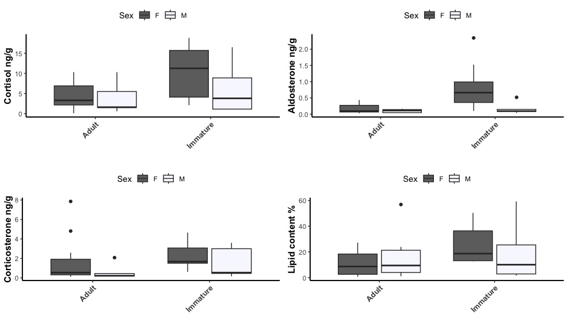
Figure XX: Hormone concentrations and lipid content in relation to age class with outliers removed. Cortisol concentrations were found significantly higher in immature individuals, whereas no significant difference was found in corticosterone concentrations. Aldosterone was significantly higher in immature females compared to immature males and adult males and females.

Analysis of hormone concentrations and lipid content in relation to body condition
Mean cortisol concentration was the lowest in samples from gray whales with fair body condition (mean ± sd = 3.79 ± 2.57 ng/g, n= 7), but it was not statistically significant from that from samples from whales that were in good c (13.0 ± 16.6 ng/g, n= 6 ) or poor (7.8 ± 8.7 ng/g, n= 16) condition (Kruskal-Wallis chi-squared = 0.7, df = 2, p-value = 0.7). Mean corticosterone concentration was elevated in samples from whales in poor body condition ( 2.11 ± 2.24 ng/g, n= 14), but it was not statistically significant from that from whales in good (0.8 ± 0.6 ng/g, n= 6 ) or fair (0.6 ± 0.7 ng/g, n= 7) condition (Kruskal-Wallis chi-squared = 0.9, df = 2, p-value = 0.6).
Mean aldosterone concentration was lowest in samples from whales in fair body condition (0.2 ± 0.09 ng/g, n= 7), but it was not statistically significant from that from whales in good (0.4 ± 0.3 ng/g, n= 6 ) or poor (0.4 ± 0.7 ng/g, n= 14) condition (Kruskal-Wallis chi-squared = 0.8, df = 2, p-value = 0.6, Fig 4).
No significantly difference was found in lipid content among samples from whales in any body conditions (Kruskal-Wallis chi-squared = 4.1, df = 2, p-value = 0.13).

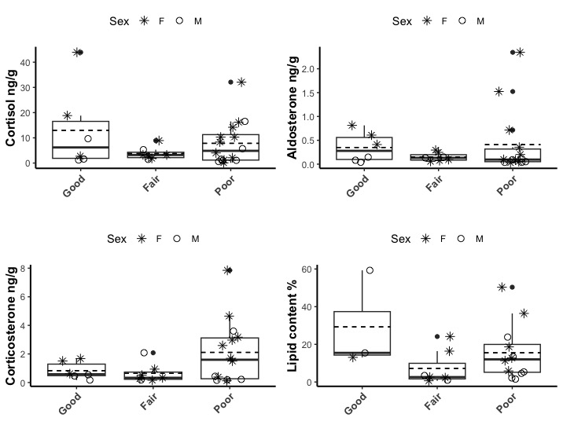
Figure 4: Hormone concentrations and lipid content in relation to body conditions

Analysis of hormone concentrations in relation to cause of death
Mean cortisol concentrations were 12.80 (±12.87) ng/g for samples in the trauma category, followed by 6.51 (±8.83) and 5.1 (±3.58) ng/g for samples in the nutritional stress and undetermined category and 3.8 (±3.68) and 1.7 (±1.00) ng/g for samples in the entanglement and predation categories (Fig. 3a). However, the ANOVA test perfumed on the log -transformed values found no significant difference (F: 1.3, df= 4, p-value: 0.31). Analytical results did not change when two outliers, both with mean cortisol > 20 ng/g, were removed.
Mean (± standard deviation) concentrations of corticosterone were 1.06 (± 1.18) ng/g for samples in the Trauma category, 3.82 (± 3.17) ng/g, 1.26 (± 1.44) ng/g for samples in the Nutritional stress categories (UME and not), and 1.77 (± 1.74) and 0.59 (± 0.65) ng/g for samples in the Entanglement and Predation categories (Fig. 3b). As for cortisol, the ANOVA test performed on the log-transformed values indicated no significant difference (F=1.5, df=4, p-value=0.23).
Similarly for aldosterone, one obvious outlier was removed from the analysis. Mean (± standard deviation) aldosterone concentrations were 0.27 (± 0.25) ng/g for samples in the Trauma category, followed by 0.35 (± 0.66) ng/g and 0.25 (± 0.18) ng/g for samples in the Nutritional stress categories (UME and not), and 0.33 (± 0.26) and 0.39 (± 0.39) ng/g for samples in the Entanglement and Predation categories (Fig. 3c). However, there was no significant difference (Kruskal-Wallis: chi-squared = 2.03, df = 4, p-value = 0.73).
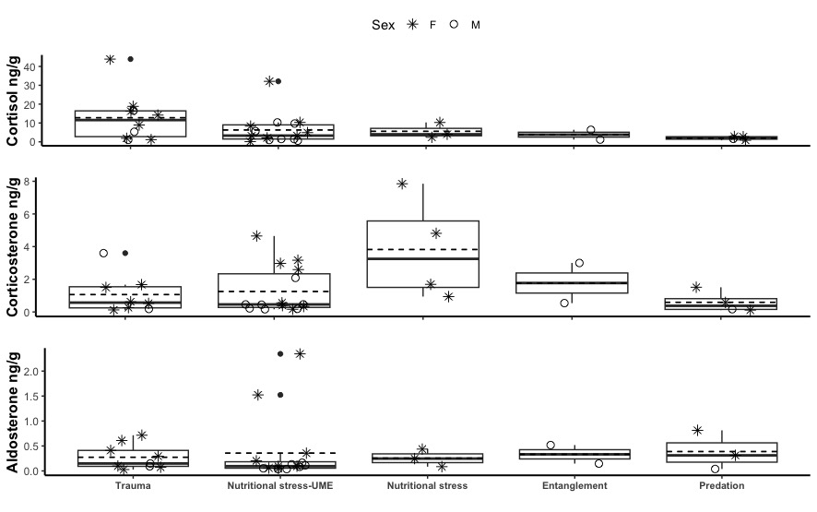
Figure 3: Hormone concentrations across cause of death

Figure 4: Hormone concentrations and lipid content in relation to body conditions

Analysis of hormone concentrations across blubber depth.
The means and standard deviations of all three corticosteroids were the greatest in the surface blubber layer for female gray whales, while the values were similar in all blubber depths for males (Table 1.)

Table 1: Summary of hormone concentrations and lipid content in each layer of blubber.
 |  | Cortisol ng/g |  |  | Corticosterone ng/g |  |  | Aldosterone ng/g |  |  | Lipid content %
Blubber Depth | Sex | Mean | Standard deviation | Range | Mean | Standard deviation | Range | Mean | Standard deviation | Range | Mean | Standard deviation | Range
Surface | F | 11.33 | 14.24 | 0.11-43.91 | 1.48 | 1.20 | 0.16-3.17 | 0.34 | 0.53 | 0.05-1.52 | 14.53 | 11.01 | 2.29-36.4
Medium | F | 4.83 | 6.22 | 0.12-16.95 | 0.76 | 0.47 | 0.28-1.52 | 0.05 | 0.03 | 0.02-0.11 | 0.93 | 0.66 | 0.12-1.6
Bottom | F | 8.58 | 9.11 | 0.17-27.8 | 0.71 | 0.62 | 0.07-1.75 | 0.05 | 0.04 | 0.02-0.12 | 0.24 | 0.27 | 0.03-0.7
Surface | M | 3.89 | 4.06 | 0.58-10.33 | 0.56 | 0.63 | 0.16-2.08 | 0.07 | 0.04 | 0.04-0.13 | 23.63 | 24.83 | 0.99-59.3
Medium | M | 2.95 | 3.58 | 0.52-10.96 | 0.79 | 0.69 | 0.15-1.87 | 0.07 | 0.11 | 0.01-0.26 | 3.65 | 3.19 | 0.53-8.29
Bottom | M | 3.06 | 3.70 | 0.42-10.87 | 0.59 | 0.37 | 0.13-1.16 | 0.15 | 0.24 | 0.003-0.43 | 12.81 | 16.08 | 0.28-34.3

Based on AICc, the model for blubber depth as a predictor for hormone concentrations was better when compared to the null model for cortisol concentrations. The post hoc test found significant difference in cortisol concentrations between the Surface and Medium blubber layers (EMMeans t (34.2) = 2.5, p = 0.05). When three outliers (cortisol > 25 ng/g) were removed, the difference was no longer significant.
For corticosterone, the null model was had a lower AICc (116.7) when compared to the model with Blubber death as predictor (AICc=120.6). Results did not change when three outliers were removed. Similarly, the null model was the best model for aldosterone concentrations (AICc= 17.5) when compared to the model with blubber depth (AICc=25.2). Results did not change when one outlier was removed.
For lipid content, the model with blubber depth was found to be the best model (AICc= 278.3). Based on the post hoc test results the lipid content in the surface layer was significantly different from those in the medium (EMM t(19.1) = 3.4 , p= 0.01) and bottom (t(19.8) = 3.3, p= 0.01) layers. Two samples were identified as outliers as both had lipid content > 50%. When removed, the lipid content in the surface was significantly different from that in the medium layer (t(18.2)= 2.8, p= 0.03), but not the bottom layer, 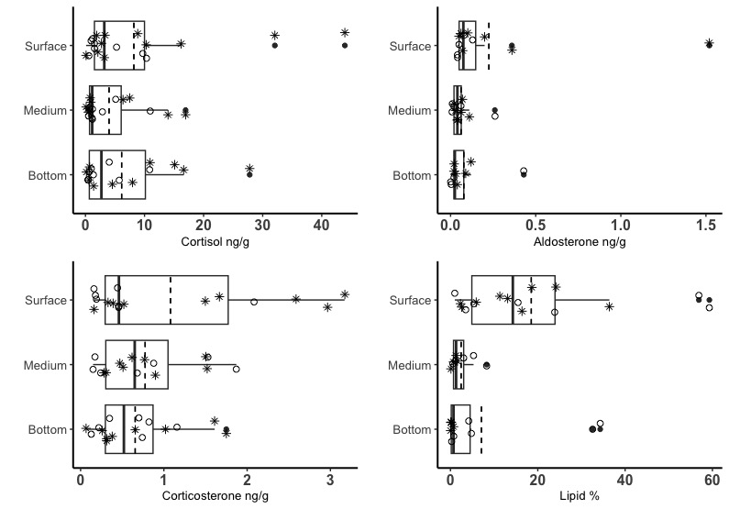
Figure 2: Hormone concentrations(ng/g) and lipid content (%) across blubber depth in samples from stranded female (*) and male (°) gray whales.

